Supplementary material to the manuscript by Karolova et al.: PD-1, PD-L1 and PD-L2 expression in Mantle cell lymphoma and healthy population

Content:

- Table S1a and S1b - detailed information about patients with MCL and CLL (pp 2-4)
- Table S2a and S2b - flow cytometry panels of antibodies used for the analysis (pp 4-5)
- Statistical analysis – details (pp 5-6)
- Descriptive statistics and Table S3 (pp 6-7)
- Figure S1 - Whisker-plots of PD-1/PD-L1/2 expression on B and T cells of newly diagnosed MCL and CLL (pp 8-9)

Table S1. Detailed information about patients with new diagnosis of MCL and CLL
a. MCL patients
Samples | DG | REL | CS | Date of last control / death
MCL1 | 06/2013 | / | IVA | x 28/04/2014
MCL2 | 01/2014 | / | IVBS | 06/06/2019
MCL3 | 03/2013 | / | IVSA | x 03/05/2018
MCL4 | 13/01/2014 | / | IVA | 10/01/2019
MCL5 | 12/11/2013 | 03/2015 | IVBS | x 05/08/2015
MCL6 | unknown |  | IV | 04/04/2019
MCL7 | 04/2013 | 17/12/2013 | IVBS | x 18/02/2014
MCL8 | 04/2013 | / | IVA | 11/04/2019
MCL9 | 11/12/2013 | / | IVB | 18/01/2019.
MCL10 | unknown |  |  | x 30/10/2013
MCL11 | 06/2013 | / | IVA | 04/04/2019.
MCL12 | 03/2013 | / | IVBS | 18/06/2019
MCL13 | 22/05/2013 | 23/04/2015 | IVA | x 11/06/2016
MCL14 | 01/2014 | 01/2015 | IVA | 20/06/2019
MCL15 | 12/02/2014 | / | IVA | 06/06/2019
MCL16 | unknown |  |  | x 04/09/2016
MCL17 | 04/2013 | 23/02/2017 | IVA | 18/04/2019
MCL18 | 06/2013 | 16/09/2014 | IVAS | x 06/12/2015
MCL19 | 07/2013 | / | IVAS | 19/02/2019
MCL20 | 03/2014 | 05/2016 | IVBS | x 28/09/2017
MCL21 | 02/2014 | / | IVB | x 02/01/2019
MCL22 | 05/2015 | / | IVAS | 14/03/2019
MCL23 | 10/2015 | / | IVASB | 20/06/2019
MCL24 | 02/2015 | / | IVA | 20/09/2018
MCL25 | 02/2015 | / | IVA | 14/05/2019
MCL26 | 04/2015 | / | IVBS | 18/06/2019
MCL27 | 09/2014 | 20/06/2018 | IVA | x 03/02/2019
MCL28 | 09/02/2015 | / | IVAB | 06/09/2018
MCL29 | 01/2016 | / | IVB | 09/04/2019
MCL30 | 06/2015 | / | unknown | 29/01/2018
MCL31 | unknown |  |  | x 29/01/2015
- CLL patients
Samples | DG | REL/PROG | CS | Date of last control / death
CLL1 | 15/09/2011 | 11/03/2015 | Rai I | 25/07/2017
CLL2 | 09/1999 | / | Rai 0 | 24/05/2019
CLL3 | 06/2005 | 05/2015 | Rai 0 | 26/04/2019
CLL4 | 01/2003 | 18/01/2016 | Rai 0 | 02/05/2019
CLL5 | 23/05/2012 | 30/03/2015 | Rai II | 07/06/2019
CLL6 | 12/2006 | 12/11/2013 | Rai I | x 28/04/2015
CLL7 | 08/2008 | 09/2013 | Rai 0 | 04/06/2019
CLL8 | 03/2007 | 10/2010 | Rai I | x 27/06/2018
CLL9 | unknown
CLL10 | unknown |  |  | 10/06/2019
CLL11 | unknown |  |  | 12/02/2019
CLL12 | 01/2013 | / | Rai I | 31/05/2019
CLL13 | 04/2003 | 01/2015 | Rai I | x 07/03/2019
CLL14 | 02/02/2015 | / | / | 28/02/2019
CLL15 | unknown |  |  | 28/06/2019
CLL16 | unknown |  |  | x 12/02/2019
CLL17 | 11/ 2014 | / | IIIa | 17/05/2019
CLL18 | 2013 | 09/2015 | unknown | 11/04/2016
CLL19 | unknown |  |  | 02/01/2019
CLL20 | 09/2015 | 11/2016 | IVB | x 12/08/2018
CLL21 | unknown |  |  | 28/11/2018
CLL22 | unknown |  |  | x 04/02/2016
CLL23 | unknown |  |  | x 30/08/2016
CLL24 | unknown |  |  | 15/04/2019
CLL25 | 08/2013 | 11/2013 | Rai II | x 26/07/2016
CLL26 | 2008 | 12/2013 | Rai 0 | 28/06/2019

CLL = chronic lymphocytic leukaemia, CS = clinical stage, DG = date of the diagnosis, MCL = Mantle cell lymphoma, PROG = date of the progression, REL = date of the relapse, x = death.
2.
Table S2. Flow cytometry panels of antibodies used for the analysis
a. 6-color tube for characterization of B-cells
Antigen | Fluorochrome | Clone | Isotype | Target | Type | Manufacturer
CD45 | Krome Orange | J33 | mouse | human | monoclonal | Beckman Coulter
CD274 | FITC | MIH1 | mouse | human | monoclonal | BD Biosciences
CD279 | PE | eBioJ105 | mouse | human, monkey | monoclonal | eBioscience
CD5 | PerCP-Cy5.5 | L17F12 | mouse | human | monoclonal | Sony
CD19 | PE Cy7 | J3-119 | mouse | human | monoclonal | Beckman Coulter
CD273 | APC | MIH18 | mouse | human | monoclonal | Biolegend

b. 7-color tube for characterization of T-cells
Antigen | Fluorochrome | Clone | Isotype | Target | Type | Manufacturer
CD4 | Pacific Blue | RPA-T4 | mouse | human | monoclonal | Sony
CD45 | Krome Orange | J33 | mouse | human | monoclonal | Beckman Coulter
CD8 | FITC | B9.11 | mouse | human | monoclonal | Beckman Coulter
CD279 | PE | eBioJ105 | mouse | human, monkey | monoclonal | eBioscience
CD197 | PerCP-Cy5.5 | 150503 | mouse | human | monoclonal | BD Biosciences
CD45RA | APC | HI100 | mouse | human | monoclonal | BD Biosciences
CD3 | APC-Alexa Fluor 750 | UCHT1 | mouse | human | monoclonal | Beckman Coulter

3.

Statistical analysis – details
In case of expression profile of PD-1/PD-L1/2 molecules on B and T cells of healthy population, we used mean fluorescent intensity to evaluate the expression level of these molecules and employed scatterplots with calculated regression lines to demonstrate linear relationship between the age and expression of those molecules in our data set. The strength of linear relationship between the variables was evaluated by Pearson's correlation coefficients (Pearson r). To assess the statistical significance of the relationship we report bootstrap estimate of P-value and bootstrap 95 % confidence intervals for the Pearson's correlation coefficient (5,000 bootstrap replications being employed). The individual significance level of 5 % was selected arbitrarily before the analysis.
In expression analysis of PD-1, PD-L1 and PD-L2 molecules on the surface of B cells and T cells from peripheral blood of patients with newly diagnosed MCL and CLL we show particular distributions in the form of deciles and boxplots. To assess the statistical significance of differences in distributions in population of all patients and of all healthy samples the non-parametric Mann-Whitney statistical hypothesis test was carried out. As we simultaneously present results of 36 Mann-Whitney tests about identical distributions in both populations, the Bonferroni correction of 5% simultaneous significance level (selected arbitrarily before the analysis) was utilized, resulting in individual significance level of 0.1389 %.
We also performed detailed descriptive statistics of expression profile of PD-1, PD-L1 and PD-L2 molecules and present particular distributions in CLL, MCL and CTRL data sets. The level of expression was evaluated by mean fluorescent intensity and percentage representation (see Supplemental Table 3).
As for the analysis of specific subpopulations of T lymphocytes in MCL and expression of PD-1 molecule on the surface of these subpopulations we compared level of expression of PD-1 molecule (evaluated by MFI or percentage analysis) in 20 aged matched healthy controls and compared them with 31 samples of patients with MCL and 26 samples of patients with CLL. We simultaneously present results of 66 Mann-Whitney tests about identical distributions in both populations. The Bonferroni correction of 5 % simultaneous significance level (selected arbitrarily before the analysis) was utilized, resulting in individual significance level of 0.0758 %.

4.

Descriptive statistics

Detailed descriptive statistics of expression profile of PD-1/PD-L1/2 molecules and complex descriptive statistics of PD-1 surface expression on T cell subpopulations available at: Table S3 (https://lymphoma-lab.lf1.cuni.cz/supplemental-data-file-karolova-et-al).
5.
Fig. S1. Whisker-plots of PD-1/PD-L1/2 expression on B and T cells of newly diagnosed MCL and CLL in comparison with healthy controls (CTRL)
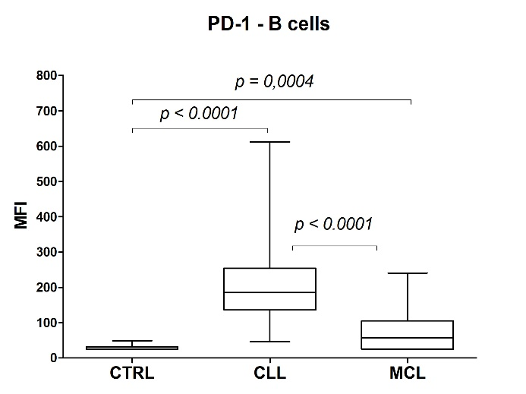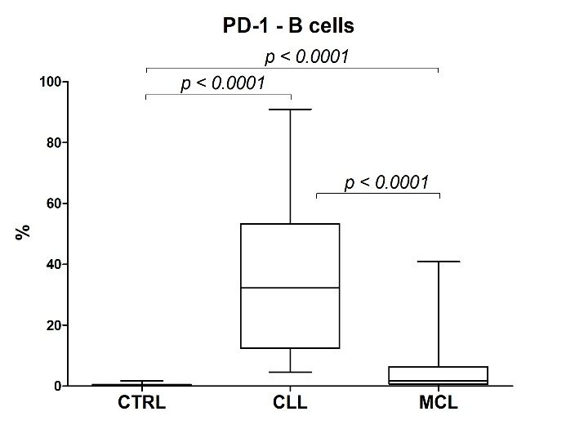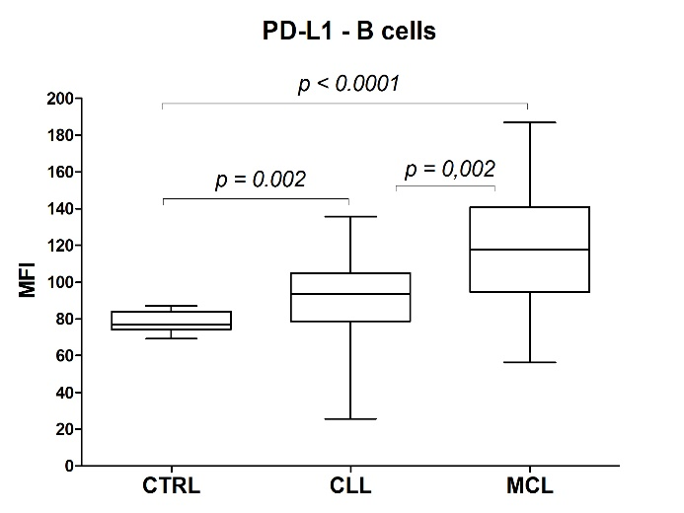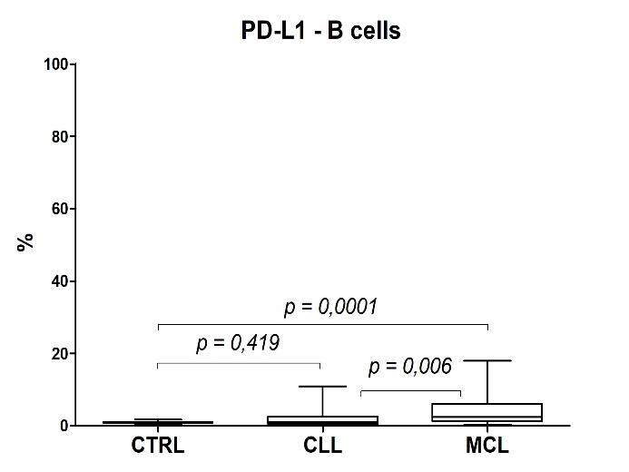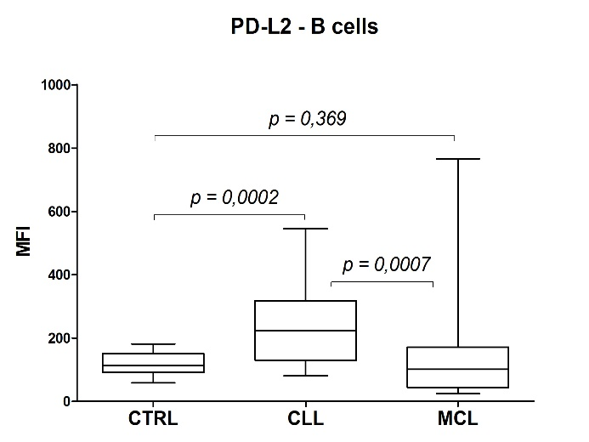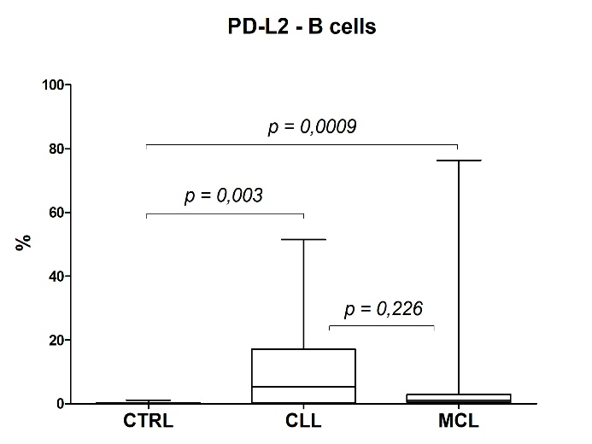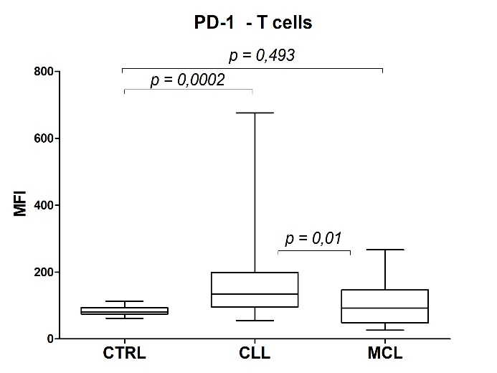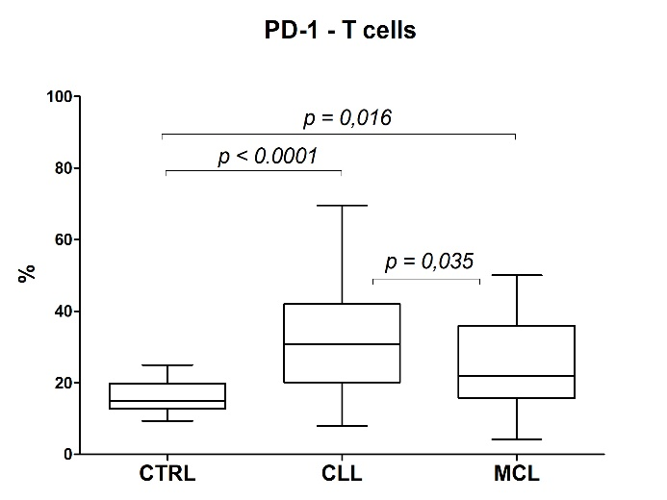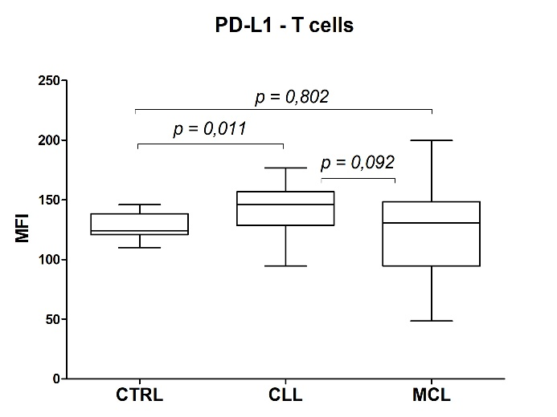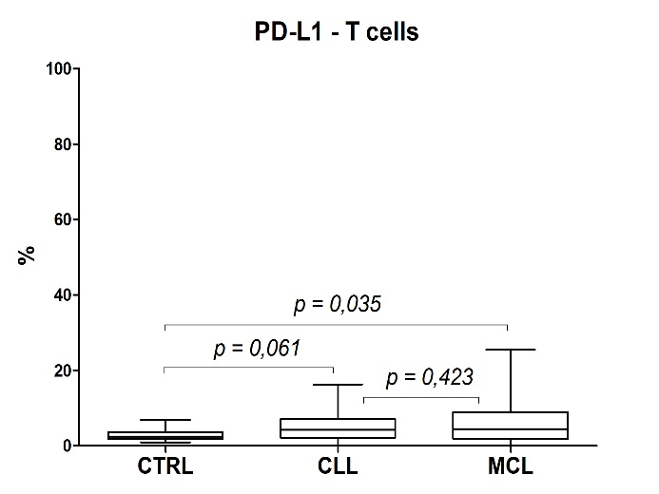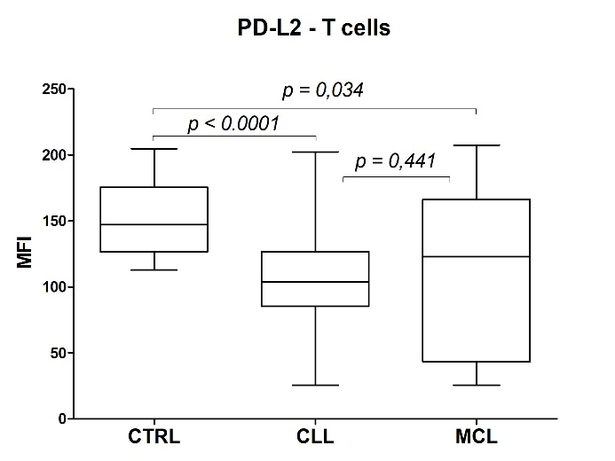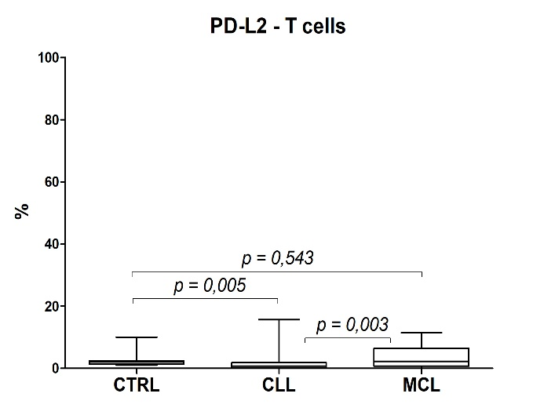

Fig. S1: Whisker-plots of PD-1 and PD-L1/L2 surface expression on B and T cells of newly diagnosed MCL and CLL. The figures on the right side show the expression level illustrated by MFI, on the left side by the percentage of positive cells (%). MFI = mean fluorescence intensity, CTRL = healthy controls, MCL= mantle cell lymphoma, CLL = chronic lymphocytic leukaemia.

