**Supplemental Data File**

**Concurrent TP53 and CDKN2A gene aberrations in patients with newly diagnosed mantle cell lymphoma correlate with chemoresistance and call for innovative upfront therapy**

**Supplemental Table 1. Univariate analysis: correlation of analyzed gene aberrations and selected clinical and laboratory parameters with survival**

1. **Event-free survival**

|  |  |  |  |
| --- | --- | --- | --- |
|  | **HR** | **95% CI** | **p** |
| ***TP53*** | 2.2 | 1.5 - 4.0 | <0.001 |
| ***CDKN2A*** | 3.0 | 2.4 - 6.8 | <0.001 |
| ***RB1*** | 2.0 | 1.3 - 3.7 | 0.003 |
| ***MYC*** | 1.9 | 1.3 - 3.8 | 0.004 |
| ***CDK4*** | 2.3 | 1.5 - 7.5 | 0.005 |
| ***BCL2*** | 1.9 | 1.2 - 4.0 | 0.016 |
| ***ATM*** | 1.3 | 0.8 - 2.2 | 0.303 |

1. **Overall survival**

|  |  |  |  |
| --- | --- | --- | --- |
|  | **HR** | **95% CI** | **p** |
| ***TP53*** | 2.3 | 1.4 - 4.3 | 0.002 |
| ***CDKN2A*** | 3.2 | 2.4 - 8.1 | <0.001 |
| ***RB1*** | 2.2 | 1.4 - 4.6 | 0.003 |
| ***MYC*** | 1.7 | 1.0 - 3.5 | 0.068 |
| ***CDK4*** | 3.0 | 2.2 - 18.2 | 0.001 |
| ***BCL2*** | 2.4 | 2.3 - 10.9 | <0.001 |
| ***ATM*** | 1.2 | 0.7 - 2.3 | 0.504 |

1. **Event-free survival**

|  |  |  |  |
| --- | --- | --- | --- |
|  | **HR** | **95% CI** | **p** |
| **Male sex** | 1.5 | 0.9 - 2.3 | 0.144 |
| **Ki-67** | 2.0 | 1.2 - 3.8 | 0.011 |
| **B-symptoms** | 2.7 | 1.9 - 5.1 | <0.001 |
| **Nodal involvement** | 3.4 | 1.1 - 4.3 | 0.026 |
| **EH involvement** | 1.5 | 1.0 - 2.5 | 0.062 |
| **Splenomegaly** | 1.8 | 1.0 - 2.8 | 0.047 |
| **Bulky disease** | 1.9 | 1.3 - 3.4 | 0.005 |
| **Complex karyotype** | 2.7 | 1.4 - 14.7 | 0.014 |

1. **Overall survival**

|  |  |  |  |
| --- | --- | --- | --- |
|  | **HR** | **95% CI** | **P** |
| **Male sex** | 2.1 | 1.1 - 3.3 | 0.032 |
| **Ki-67** | 2.2 | 1.1 - 4.7 | 0.026 |
| **B-symptoms** | 2.8 | 1.8 - 5.5 | <0.001 |
| **Nodal involvement** | 1.9 | 0.7 - 4.0 | 0.255 |
| **EH involvement** | 1.5 | 0.9 - 2.7 | 0.149 |
| **Splenomegaly** | 1.2 | 0.6 -2.2 | 0.624 |
| **Bulky disease** | 1.5 | 0.8 - 2.7 | 0.185 |
| **Complex karyotype** | 3.9 | 2.9 - 58.7 | 0.001 |

**Legend:** EH= extrahematological involvement, i.e. extranodal involvement besides bone marrow involvement; statistically significant results are highlighted in gray

**Supplemental Table 2. Distribution of the analyzed gene aberrations**

**Legend:** Numbers represent type of aberration: 0 = not available / not able to analyze, 1 = normal finding,2 = monoallelic deletion, 3 = bialellic deletion, 4 = monosomy, 5 = nullisomy, 6 = amplification, 7 = gain, 8 = trisomy, 9 = tetrasomy, 10 = *MYC* rearrangement, 11 = t(11;14), 12 = *CCND1* rearrangement, 13 = complex conventional caryotype, 14 = *TP53* mutation, Y = yes, N = no



**Supplemental Table 3. *TP53* mutation types and positions**

**Legend:** VAF = variant allele frequency

**Supplemental Table 4. Univariate analysis of *TP53* mutation and *TP53* deletion**

1. **Event–free survival**

|  |  |  |  |
| --- | --- | --- | --- |
|  | **HR** | **95% CI** | **p** |
| ***TP53* del** | 2.3 | 1.2 - 32.8 | 0.04 |
| ***TP53* mut** | 3 | 1.9 - 15.1 | 0.002 |
| ***TP53* del+mut** | 2.3 | 1.5 - 5.3 | 0.002 |

1. **Overall survival**

|  |  |  |  |
| --- | --- | --- | --- |
|  | **HR** | **95% CI** | **p** |
| ***TP53* del** | 3.8 | 1.5 - 105.6 | 0.021 |
| ***TP53* mut** | 3.7 | 2.6 - 26.9 | <0.001 |
| ***TP53* del+mut** | 2.1 | 1.1 - 5.1 | 0.024 |

**Supplemental Figure 1. Survival parameters in the *TP53* mutation and *TP53* deletion cohorts**

1. **Event-free survival B. Overall survival**



**Legend:** Subcohort „Isolated *TP53* deletion” includes all patients with deletion of *TP53*, but without mutation of *TP53*, while in subcohort „Isolated *TP53* mutation” are patients with detected mutation of *TP53*, but without deletion. Subgroup „*TP53* mutation and deletion” includes 31 patients with mutation and deletion of *TP53*. Only 113 patients investigated by both FISH and NGS were included in this analysis. EFS= event-free survival, OS= overall survival

**Supplemental Figure 2. Random Forest analysis of analyzed aberrations**

**A:**

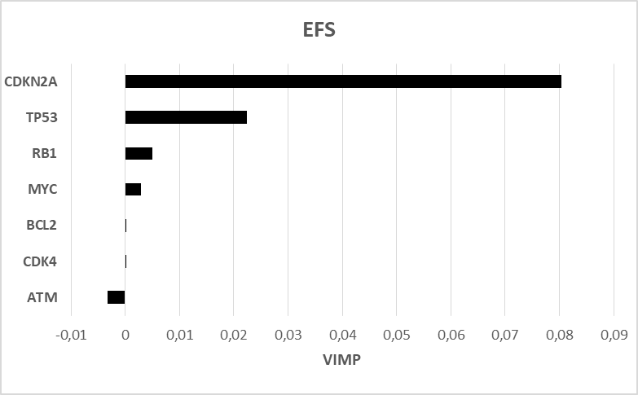

**B:**

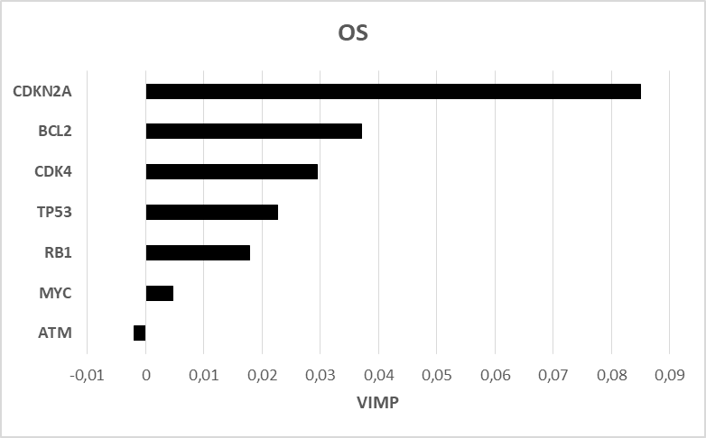

**C:**

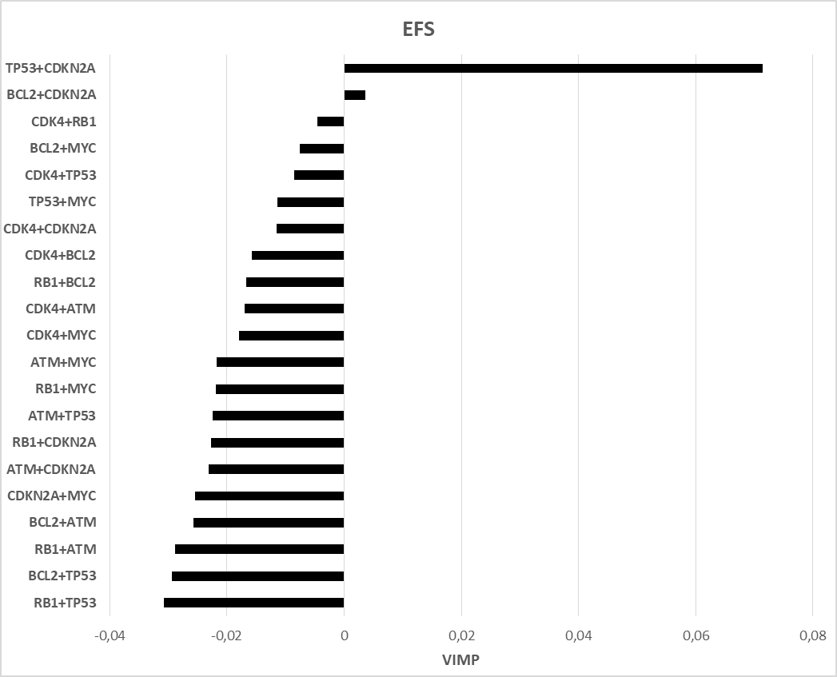

**D:**

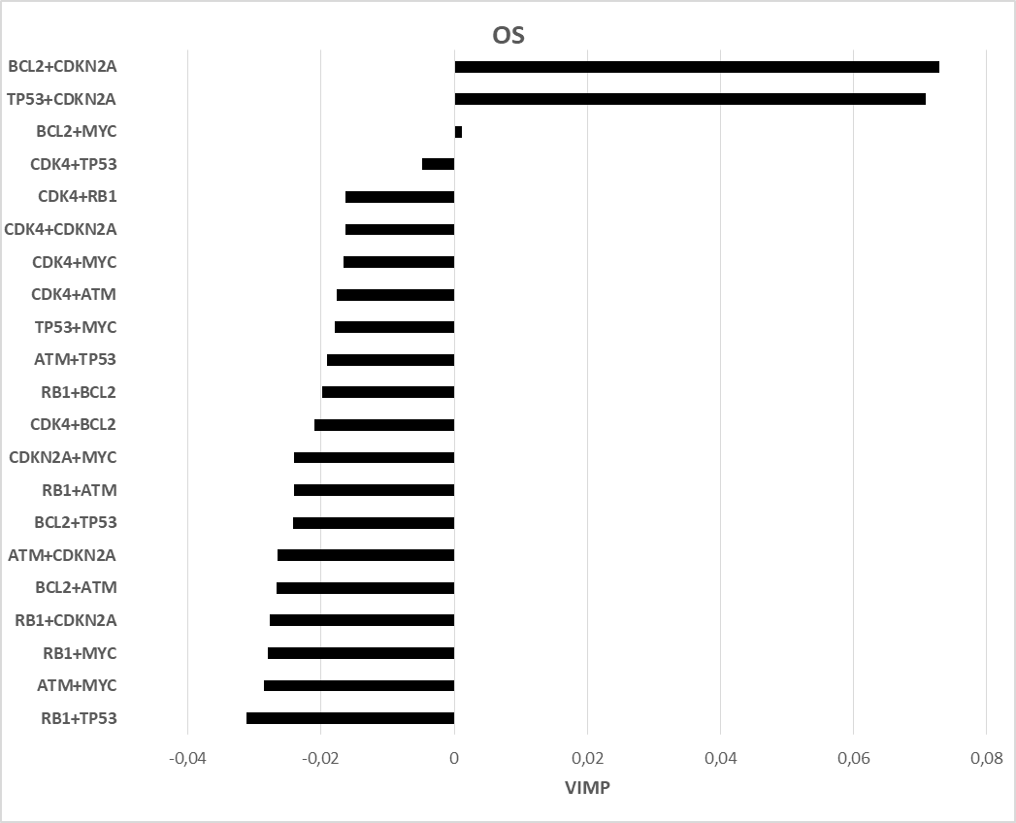

**Legend:** Positive VIMP values indicate that the variable increases the prediction accuracy of random forest analysis, whereas negative or near-zero values have no effect on survival prediction. EFS = event-free survival; OS = overall survival.

**Supplemental Table 5. Baseline characteristics and response to therapy of the patients with concurrent aberration of TP53 and CDKN2A (compared to remaining patients)**

|  |  |  |  |  |
| --- | --- | --- | --- | --- |
|  | ***TP53del/mut* + *CDKN2Adel*** | | **The remaining pts with bone marrow involvement ≥ 5%** | |
|  | N | % | N | % |
| **All patients** | 24 | 19 | 102 | 81 |
| **M** | 19 | 79 | 69 | 68 |
| **F** | 5 | 21 | 33 | 32 |
| **Age (median; years)** | 70 | | 67 | |
| **Age (range; years)** | 46 - 79 | | 29 - 82 | |
| **< 65 years** | 8 | 33 | 39 | 38 |
| **≥ 65 years** | 16 | 67 | 64 | 63 |
| **Ki-67 ≥ 30%\*** | 11 | 85 | 25 | 40 |
| **MIPI 1** | 1 | 4 | 18 | 18 |
| **MIPI 2** | 4 | 17 | 25 | 25 |
| **MIPI 3** | 19 | 79 | 59 | 58 |
| **B-symptoms** | 17 | 71 | 35 | 34 |
| **Nodal involvement** | 21 | 88 | 87 | 85 |
| **Splenomegaly** | 19 | 79 | 70 | 69 |
| **Extra-hematological involvement** | 11 | 46 | 39 | 38 |
| **Bulky disease (≥ 5 cm)** | 11 | 46 | 34 | 33 |
| **CNS involvement\*\*** | 8 | 33 | 9 | 9 |
| **Intensified therapy** | 8 | 33 | 29 | 28 |
| **R-CHOP-like therapy** | 10 | 42 | 61 | 60 |
| **Palliative therapy** | 5 | 21 | 3 | 3 |
| **Watch and wait** | 0 | 0 | 7 | 7 |
| **Died before initiation of therapy** | 1 | 4 | 2 | 2 |
| **Died during induction\*\*\*** | 4 | 17 | 5 | 5 |
| **ORR (CR/PR)** | 9 | 38 | 81 | 79 |
| **CR** | 4 | 17 | 57 | 56 |
| **PR** | 5 | 21 | 24 | 24 |
| **SD** | 3 | 13 | 1 | 1 |
| **PD** | 7 | 29 | 8 | 8 |
| **Event** | 23 | 96 | 55 | 54 |
| **Relapse** | 17 | 71 | 36 | 35 |
| **Death\*\*** | 19 | 79 | 36 | 35 |

**Legend:** M = male; F = female; MIPI = MCL international prognostic index; BM = bone marrow; CNS = central nervous system; ORR = overall response rate; CR = complete remission; PR = partial remission; SD = stable disease; PD = progressive disease; response was assessed by international workshop criteria published by Cheson B et al in 1999(7); * of the analyzed patients, ** anytime from diagnosis until database lock, *** after initiation of therapy, before restaging; differences > 20% between cohorts are highlighted in gray